CS&M  Control System & Modeling |  | S.T.I.E  Schneider Toshiba Inverter
Modelling Winder/Unwinder Systems

Key words : | Software Architecture
 | Name |  | Role / Responsibilities |  | Date
Issued by : | Jaouher Romdhane |  | R&D Engineer |  | 03/02/2025
Checked by :
Approved by :

Change Record
Version | Date | Author | Description
01 | 03/02/2025 | J.Romdhane | Initialized document

Open issues
Info: To mark questions and open issues just format the text with “Open issue”

Info: To mark questions and open issues just format the text with “Open issue” 2

Table of Contents
1. Introduction 4
1.1. Objective of the deliverable 4
1.2. Terminology 4
1.3. References 4
2. Control Strategies for Winder/Unwinder Systems 5
2.1. General Design and structure 5
2.2. Winding technique 5
2.3. Web mechanics 6
2.4. Methods of controlling the tension of web 6
2.4.1. Draw control 6
2.4.2. Open Loop Torque Control 6
2.4.2.1. Open Loop Torque Control (for inline Tensioning) 7
2.4.2.2. Open Loop Torque Control with Speed 7
2.4.2.3. Open Loop Torque Control with Speed and Torque Feed Forward 8
2.4.2.4. Torque Follower Control Modes 8
2.4.3. Closed-loop Tension Control 8
2.4.3.1. Tension feedback with Torque (for inline Tensioning) 9
2.4.3.2. Tension feedback with Speed and Torque Feed Forward 9
2.4.4. Closed-Loop dancer roll control 9
3. SE Winder/Unwinder solution 11
3.1. ATV71 with card option VW3A508 11
3.2. TRACTEL Solution 12
4. Competitors Solutions 13
4.1. ABB 13
4.2. Rockwell automation 14
4.3. Siemens 16
4.4. Lenze 18
5. Bibliography 21

Introduction

Objective of the deliverable
The goal of this document is to present the current state of art of control strategies for winder/unwinder systems.

Terminology
Acronym | Name | Definition
Web | Web | A web is defined as the material being transported through the machine. It is sometimes referred to as a 'sheet' or 'strip.
Strip | Strip | The strip is defined as the material that is being transported through the machine.
Section | Section | A Web Handling Machine is broken up into sections. A section consists of one or more drives used to propel the material through the line.

References
Template Documents | Reference / Date

Applicable Documents | Reference / Date

Reference Documents | Reference / Date

Winding Machine

Introduction

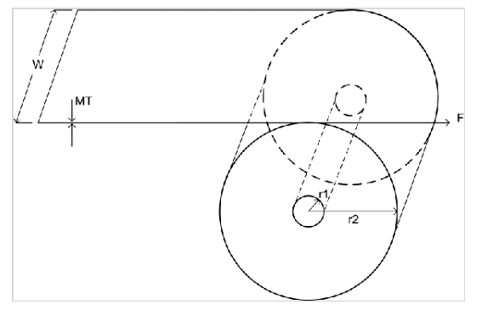
Figure 1: Physical representation of Winder.
The simulation requires the following parameters and variables:
- W: roll width
- r1: core radius
- r2: roll radius
- MT: material thickness
- MV: Material mass per unit volume
- L: Material length
- M: Material mass
- Jr: Material inertia
- Jc: Winder core inertia
- Bw: Winder viscous friction coefficient

This block computes various winder variables using the following equations.
Surface speed:

Bibliography

[1] « Tension control_9329-RM002B-EN-E ».

